**Software Requirements Specification**

1. **Introduction**

The purpose of writing this manual is to clarify the requirements of the ordering system, the specific functions that the system needs to implement, the corresponding software and hardware environment required for the operation of the system, and the input and output requirements of system data. and review the basis for project work. Provide basic guidance for system database structure design, coding implementation and testing.

1. **Background**

◆ The name of the software system to be developed: based on the Android ordering system

◆ User: Catering merchants, consumers

◆ Related technologies: SSH framework, Android

1. **Target**

**3.1 Goal:** Define what functions the ordering system needs to implement, as well as the specific logic and precautions when these functions are implemented.

**3.2 user characteristic:** The users of this system are:

The first is the consumer, the general user of the system. They can use the mobile terminal to browse products and perform other operations.

The second is merchants, which provide product information and supply sources.

The third is the administrator, who maintains the server and needs to master relevant computer technology.

1. **Requirements**

**4.1 function requirement**

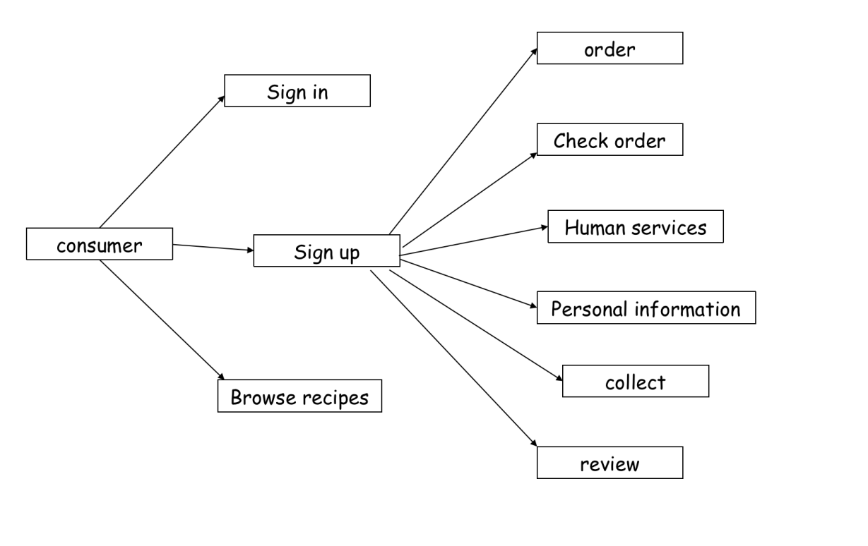

◆Registration: To register an account, users need to provide user name, password, e-mail and so on.

◆Login: The user needs to enter the account password to log in to the account.

◆Browse recipes: Users can browse products in the app without registration, display products in the form of waterfalls, and provide a variety of product browsing methods, such as: category browsing, latest products, recommended products, hot-selling products, etc.

◆Collection of goods: Users need to log in to their account to collect goods. Customers can bookmark their favorite recipes.

◆Evaluation: Users can evaluate the dishes they have ordered

◆Modify personal information: Users can modify their personal information. It is necessary to log in to the account, and users can manage their own address information, purchased products, collections, points, evaluations, etc.

◆View orders: Customers can search for nearby people or nearby businesses, and need to log in to their account.

◆Manual service: The user can contact the restaurant waiter immediately.

◆Ordering: Users can order food online without the need for a waiter

**4.2 business requirement**

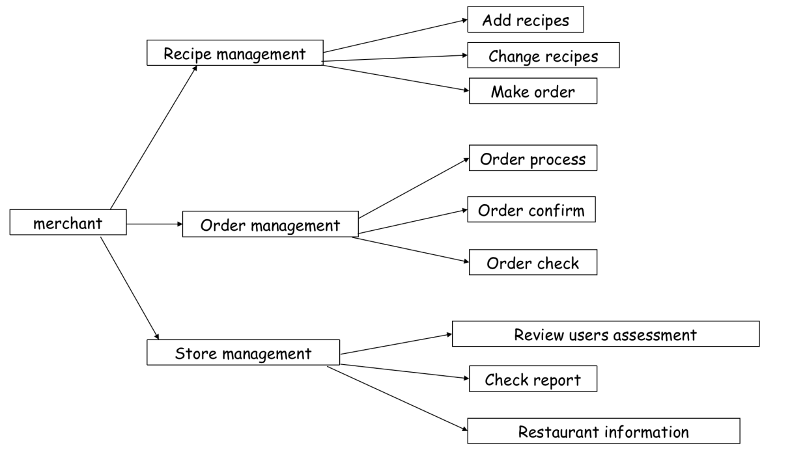

◆Add recipes: Merchants can add recipes in this shop

◆Modify the recipe: The merchant can modify the recipe information, and the merchant needs to log in.

◆Recipe delisting: Merchants can delist recipes, and merchants need to log in.

◆View store information: Merchants can view store information. Includes viewing customer reviews and viewing reports.

◆View user evaluation: Merchants can view the user's evaluation of the product, and the evaluation can be classified and displayed according to the evaluation level.

◆View report: Merchants can view the report of the store. Check the business status of the merchant.

◆Store Management: Merchants can manage their own stores. Including advertising, store decoration.

◆Order processing: The information of the user's order will be pushed here, and the merchant can take the order.

◆Order View: Merchants can view past order information

**4.3 administrator requirement**

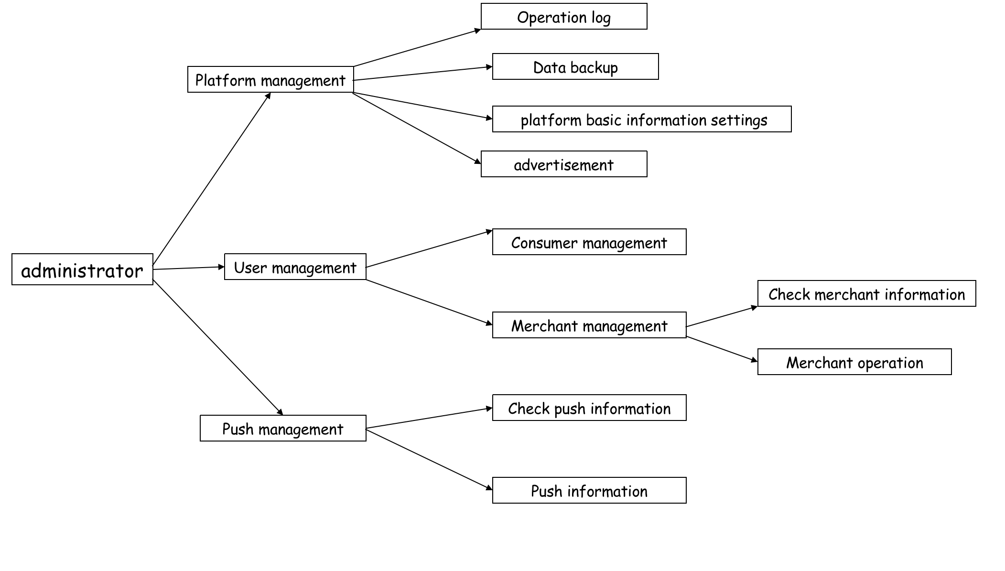

◆Platform management: the daily management and maintenance of the platform by the administrator. Including log management, database backup, setting platform-related information, bidding management, advertising, etc.

◆Log management: manage the logs generated by the platform. You can view logs or add or delete logs according to a certain period of time.

◆Database backup: used to back up the data in the database.

◆Set platform-related information: Set some basic parameters of the website, such as website name, title, domain name, etc.

◆Advertising management: Manage advertisements on the platform. Can add, delete, update, query related advertising information.

◆User management: The administrator manages users. Including business and customer management. Perform CRUD operations on user permissions and information.

◆Push management: administrators can push information to customers and businesses on the platform. Including viewing push information, push.

◆View push information: The administrator can view the pushed information according to time and category.

◆Push information: The administrator can push relevant information after a series of screening according to specific customers and businesses (with the same type of characteristics).

**4.4 system requirement**

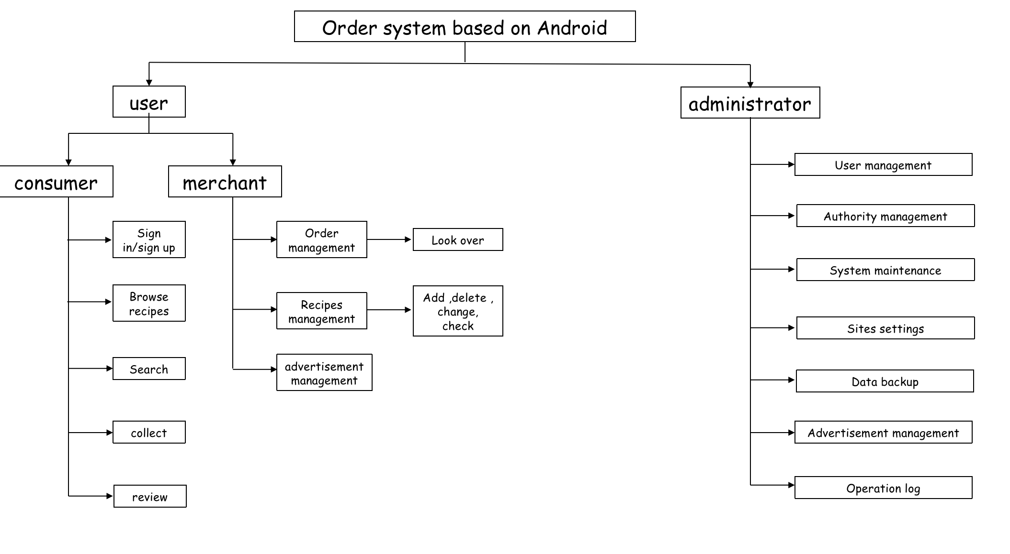

**5 Requirements for performance**

**5.1 Accuracy**

The main operating data of the system is the price of the product and the cost of the store's bidding ranking, which is accurate to 0.01 yuan.

When users search for stores and recipes, the recall rate is guaranteed, and all records containing the query keyword in the corresponding domain should be able to be found.

**5.2 Time characteristic requirements**

➢ In order to provide satisfactory services to users, behind the perfection of powerful functions, the response time of the system is also a key factor. Here we require that the response time to search should not exceed 5 seconds.

➢ When a customer places an order, the response time cannot exceed 5 seconds.

➢ When users comment on products, the information update processing time cannot exceed 10 seconds.

➢ Response speed of all other interactive functions: no more than 3 seconds;

**5.3 Flexibility**

The system's database requirements allow new relationships, or attributes, to be added as needed without degrading the system's performance. When the database changes, our corresponding system version needs to be upgraded, but the existing interface and interface will not change much, just add corresponding function buttons.

**5.4 Input and output requirements**

In order to allow users to use the system smoothly, the system must have a high operating speed. When users search for products, the system must be able to respond to operations quickly and in a timely manner, process various data and information quickly, and display the information the user needs. Therefore, the system is required to have High information speed and large main memory capacity; due to the need to store a large amount of data and information, there must also be a large enough disk capacity; in addition, the system must have reliable security measures, and data input is valid for data entry. Security checks to ensure the storage security of user information.

**5.5 Data management capability requirements**

The scale of various basic data required to run the software system and other data in the early stage is about 3000M, the average growth of data is about 100M/month, and the data growth of the system for log records is about 50M/month. The specific growth rate is determined by the frequency of use by customers and suppliers and the amount of data in the business that occurs.

**5.6 Troubleshooting Requirements**

The core part of the system is the database and the file system, which requires the database to have an instant backup function, and the data of the file system should be backed up in time. There should be no errors in normal use, and appropriate correction prompts should be given for user input errors. When the amount of data is updated to a certain limit, or the interval time reaches a certain requirement, the database can independently select backups to minimize losses caused by power outages, misoperations, and other behaviors.

Data errors generated during the running of the software will be automatically recorded in the error log by the system, and errors caused by non-network transmission will be resolved by the system administrator or software developer.

Other errors generated during the running of the software will be resolved by the software developer or the software developer with the assistance of the system administrator according to the situation.

**5.7 Other special requirements**

The security requirements of the system are very high, and sufficient permissions are required for database access and operation. Users do not have the authority to modify and update data other than their basic information, and administrators can add and modify the database. The statistics of user spending can only be modified automatically by the database, or the database administrator has the right to modify (needs the consent of the competent authority).

At the same time, it is also necessary to prevent hacker attacks. When the database system is cracked or logged in, it can complete automatic backup; when a "malicious" operation is detected, our data on the server should have an automatic drop function to reduce information. leakage and reduce economic losses. The system administrator can put the backed up data back on the server.